Kern Regional Center

STATEWIDE

REQUEST FOR PROPOSAL FY 2023-24
Financial Management Service (FMS) Submission Deadline: May 15, 2024 by 3 PM
Proposals submitted after the above deadline will not be accepted.
Bidder’s conference via Zoom, April 30, 2024 at 3pm: click here

Announcement
Regional Centers throughout California are soliciting proposals for the development of a Financial Management Service (FMS) business to support implementation of the following:

- Self-Determination Program (SDP).
- Participant Directed Services.
- Expand equitable access to restored Social Recreation services.
- Access to employment opportunities through Competitive Integrated Employment (CIE) and Paid Internship Program (PIP).

The FMS will be delivered Statewide through three separate regional service areas (South, Central, and North). An FMS service provider will be selected for each region. Note. An FMS service provider may be selected to provide the service in more than one region. Each region will independently select an FMS service provider for their respective region.
South Region | Central Region | North Region
Lead: ELARC | Lead: KRC | Lead: ACRC
SDRC | CVRC | RCRC
RCOC | TCRC | FNRC
NLACRC | IRC | RCEB
WRC | VMRC | GGRC
HRC | SARC | NBRC
SGPRC
SCLARC
FDLRC

Direct any communication or questions regarding this RFP to the respective Lead Regional Center:
- South Region at communityservices@elarc.org
- Central Region at Tomas.cubias@kernrc.org
- North Region at rfp@altaregional.org

Applications submitted with incomplete information or proposals that do not meet the basic requirements will be rejected. This Request for Proposal (RFP) does not commit Kern Regional Center to procure or contract for services or supports.

Kern Regional Center may elect to fund all, part, or none of the project, depending on funding availability as approved by the Department of Developmental Services and the quality of the proposals received. Please refer to the project description and requirements, which describes the service concept and the possible funding availability.

Total Start-up funds available for this project: up to $2,000,000 per region

RFP Calendar

April 23, 2024 | Notice of Release of Request for Proposal
April 30, 2024 | Bidder’s Conference via Zoom (Click Here)  Or log in manually with the following  Meeting ID: 812 2977 7631  Passcode: RFPFMS
May 15, 2024 by 3:00 PM | Proposal Submissions Due  Put “Statewide FMS Proposal” in the subject line.  - South Region at communityservices@elarc.org  - Central Region at Tomas.cubias@kernrc.org  - North Region at rfp@altaregional.org
May 15-22, 2024 | Evaluation of Proposals by Selection Committee
May 30-31, 2024  Time TBD | Applicant Interviews (invitation only)
June 3, 2024 | Approval issued and notification emailed to applicants
No later than June 30, 2024 | Service Provider contract fully executed

Summary of Project
Regional Centers are soliciting proposals for the development of new or the expansion of existing Financial Management Service (FMS) businesses resulting in growth in the capacity of FMS providers across the state. It is the intent of the Regional Centers to support development of FMS services that are accessible, responsive, and transparent through the use of both technology and culturally competent human resources. Every Regional Center community is in need of expanded FMS resources to support implementation of the Self Determination Program (SDP,) to expand equitable access to restored Social Recreational services and other Participant Directed Services (PDS,) and to support access to employment opportunities through the Competitive Integrated Employment (CIE) and Paid Internship Program (PIP) program.

SDP
California state law [Welfare & Institutions Code §4685.8(d)(3)(E)] requires that participants in SDP use an FMS. An FMS provider offers support to individuals by ensuring providers are properly qualified, implementing payment of service providers, and ensuring adherence to all labor and tax laws. There are three types of FMS providers:
- Bill Payer or Fiscal Agent, this model is used when goods or services are purchased from a business.
- Co-Employer, this model is used when the participant wants to share some of the employer roles and responsibilities with an FMS.
- Sole Employer, (also known as the Fiscal/Employer Agent), this model is used when a participant wants to be the direct employer of those providing services.
For participants in the Self-Determination Program, the FMS helps manage their individual budgets and spending plan. An FMS has a duty to report to the regional centers and participants to help inform the budget. An FMS does not control the budget—they execute support for the participant's needs by paying for the services they choose.
Some of the ways an FMS can help are:
  - Paying for services, including paying employees
  - Assist with hiring employees
  - Verifying provider qualification
  - Helping providers get criminal background checks
  - Helping the participant comply with employment laws and tax requirements
The FMS also makes sure the participant has funds to purchase needed services and support for the entire year. By law, the FMS is required to provide the participant and the regional center with a monthly expenditure report.
The FMS is not required and is not obligated to provide funding for services, supports, activities, and/or products which are not part of the SDP budget.

DDS Directive Subject: FINANCIAL MANAGEMENT SERVICES dated December 21, 2018.

PDS
W&I Code section 4688.22(a)(4) states, “It is further the intent of the Legislature for
regional centers to prioritize access to those services, not only by referring consumers
and their families to existing opportunities for social recreation services and camping
services, but also by funding those services directly along with the supports they may
need to access them, increasing the availability of vendors, and expediting
vendorizations accordingly.”

DDS Directive Subject: Legislative Intent and Provider Access dated 2/6/2024

CIE/PIP
In July 2016, the Welfare and Institution Code (WIC) was amended to add section 4870 to
encourage competitive integrated employment (CIE) for individuals with developmental
disabilities. CIE is full- or part-time work for which an individual who is paid minimum wage or
greater in a setting with others who do not have disabilities. Section 4870 authorizes funding to
the Department of Developmental Services (DDS) for a paid internship program (PIP).
For this service, the FMS acts as the employer of record and is responsible for payroll and
mandated employer costs. The intern, identified supporting agency, or FMS must obtain proper
documentation (i.e. time sheets) from the internship site verifying hours the intern worked. The FMS bills, and is reimbursed by the regional center.

DDS Website Employment page

Financial Management Services Provider Requirements
To provide services, an FMS provider must meet the following requirements:
- Be vendored by a regional center with accordance to general vendorization processes and requirements of Title 17, Sections 54300 – 54390.
- Meet the requirements applicable in Sections 58884, 58886, and 58887 of Title 17 of the California Code of Regulations.
- File a bond with the vendoring regional center, issued by a surety company to the State of California as principal. The amount may be no less than 20 percent of the total of all individual budgets for participants served via the FMS. The bond needs to be reviewed and renewed annually, or more frequently, if necessary, to ensure the minimum threshold is maintained. This requirement applies to the total of all individual budgets for participants served by FMS during a state fiscal year is expected to be five hundred thousand dollars ($500,000) or more.
- Make purchases and submit invoices for only those services and supports identified in the participant's individual program plan and budget.
- Provide monthly statements to the participant and regional center that include:
  - Amount of funds allocated by budget category
  - Amount spent in previous 30 days (about 4 and a half weeks)
  - Amount of funds remaining in the individual budget
- Assist in verifying service providers meet requirements, when applicable, for the services they provide. This includes licenses, certifications, education, or experiences.
- Verify individuals providing direct personal care to the participant, obtain a background check and receive clearance before providing services.
- Verify providers are not excluded individuals. Defined as those that have been placed on US Department of Health and Human Services Office of Inspectors' General List of Excluded Individuals/Entities, or Medi-Cal Suspended and Ineligible Provider List of persons, or individuals and entities that have been convicted of a criminal offense related to any of the program under Medicare, Medicaid, or the Title XX services program, including Title 17, Section 54311(a)(6).
- Verify the completion of assessment process to ensure that services are provided in settings:
  - Designed primarily or exclusively for the provision of services to people with developmental disabilities, or
  - Where individuals with developmental disabilities are grouped or clustered for the purpose of providing services
- Comply with all vendor requirements outlined in Section 54327 of Title 17, including reporting to the Kern Regional Center any special incidents, as defined in this section that the FMS has knowledge of or that has been reported to the FMS by the participant, service provider, or any other person.
- Agree to accept a monthly rate for each participant that does not exceed the rate schedule published by the Department's website.
- Applicant should have a bachelor's degree in business, accounting, finance, human services, and/or related field work. Equivalent professional work experience may be considered.
- Previous professional experience working within the human services delivery system, preferably one that supports individuals (children and adults) with developmental disabilities strongly preferred.
- Make purchases and submit invoices for only those services and supports identified in the participant's individual program plan and budget.
- Knowledge of Kern Regional center system, self-determination program.
- Must be fluent in English in both written and oral communications and place a high priority on hiring staff who speak the language(s), respect, and understand the cultures and values of the people receiving FMS services. * Please note that Kern Regional Center primary languages after English are Spanish and Vietnamese; however, the capacity to accommodate any additional languages are welcome and encouraged.
- Applicant will not discriminate in the provisions of services based on race, religion, age, disability, sex, or national origin of the individual, or their parents, guardian, or conservator.
- Upon approval, must provide proof of or acquire both Commercial General Liability and Professional Liability, Abuse and Molestation Insurance Policies in the amounts of $1 million per occurrence/$3 million aggregate with Kern Regional Center listed as additionally insured prior to finalization of the vendorization process. All Kern Regional Center within a respective regional service area will listed as additionally insured on the certificate of insurance (COI).
- Upon approval, must acquire a physical business office and a business license for the associated city with Kern Regional Center catchment area. * P.O. Boxes are only permitted as mailing addresses, and do not qualify to meet the local business office requirement.
- Upon approval, must develop and submit a first draft program design within (90) days of the award of the contract.
- The FMS will have a direct vendorization with the Lead Regional Center, (Kern Regional Center), within each regional service area, and be courtesy vendor with all other regional centers within each of the respective regional service areas

Home and Community-Based Setting (HCBS) Requirements
The FMS service provider must meet the regulations issued by the Centers for Medicare and Medicaid Services (CMS) regarding standards that must be met for home and community-based services (HCBS) to continue receiving federal funding. All services selected by an SDP participant will need to be compliant with the HCBS Final Rule. The prospective provider must ensure that services developed as part of this project are provided in accordance with the HCBS Setting Final Rule and person-centered individualized program plans that focus on the achievement of goals and individual values. https://www.dds.ca.gov/initiatives/hcbs/

Qualifications Sought in a Provider
- Proven history of fiscal responsibility, stability, and soundness
- Provide proof of any current and active degrees, credentials, licenses, training certificates and/or skills required or beneficial for the FMS
- An understanding of Person-Centered Practices, the IPP (Individual Program Plan) process, and the legal rights of people with developmental disabilities in California
- History of positive working relationships with the community and applicable government agencies. If applicant is a current service provider, applicant must be in good standing with the regional center
- Proven history in project development, including the ability to complete projects, meet project timelines and manage a project of this size and scope
- Administrative capacity to complete the project and implement the service in a timely fashion
- The ability to build positive relationships and communicate with people of diverse backgrounds and abilities
- Relationship management through excellent customer service- with people receiving services, their service coordinators, employees, families, and vendors primarily through phone and email interactions
- Excellent written and oral communication skills
- Excellent organizational and administrative skills
- Ability to provide the FMS services across the regional service area for which you are applying for including area that may be remote.

Eligible Applicants
Any individual, partnership, corporation, association, or private-for-profit or non-for-profit agency may submit a proposal. Applicants must disclose any potential conflicts of interest per Title 17, Section 54500*. Applicants, including members of governing boards, must be in good standing in regard to all services vendored with any regional center. For partnership submissions, all partners should have full knowledge of the contents of the proposal submitted and must demonstrate commitment to the project during start-up as well as on-going operations. Employees of the State and the regional center may apply but must cease employment prior to becoming vendored to provide FMS services.
* Pursuant to Title 17, Section 54314, the following individuals are not eligible for vendorization:
1. Any officer or employee of the State of California.
2. Any applicant in which an officer or employee of the State of California has a financial interest.
3. Employees and board members of any regional center with a conflict of interest pursuant to Title 17, Sections 54500 through 54525.
4. Any applicant in which the regional center employee or board member has a relationship which creates a conflict of interest pursuant to Title 17, Sections 54500 through 54525, unless the conflict is eliminated or a waiver is obtained pursuant to Title 17, Sections 54522 through 54525.

The Project Proposal Must Include
- Title Page that includes the name of this project, applicant’s name, email, address, and phone number.
- Table of Contents with corresponding page numbers.
- A description of the applicant’s qualification detailing education, knowledge, and experience in the development, management, or operation of an FMS or similar financial project.
- A description of the applicant’s qualifications detailing education, knowledge, and experience providing services to individuals with developmental disabilities.
- A description of the applicant’s mission, values, and vision statements specific to providing FMS services to Regional Center individuals.
- Provide a statement outlining the applicant’s plan to serve diverse populations, including culturally and linguistically diverse populations.
- Provide examples of the applicant's commitment to addressing the needs of those diverse populations.
- Include any additional information that the applicant deems relevant to issues of equity and diversity.
- A description of prior successful collaboration with Regional Center and/or other regional centers (if applicable).
- Job Titles, Descriptions, Qualifications, and Responsibilities for each position that will be developed in the prospective FMS.
- A description on how the applicant will assist individuals with sole and/or co-employer hiring of employees.
- A description on how the applicant will monitor an individual’s SDP funds to ensure the funds will be available for the full year of the SDP budget.
- A description on how the applicant will establish contracts/agreements with all necessary entities for which the FMS will provide funding to in accordance with an individual’s SDP budget.
- A description on how the FMS will provide direct payments to the individual’s supports and service providers to ensure those payments are provided in a timely manner.
- A description of how the FMS will use technology to enhance transparency and streamline processes.
- A description on how the applicant will provider the FMS service to individual’s living in remote areas.
- A description regarding staff recruitment and retention.
- A description of the staff training plan.
- A description of how the applicant will screen interested individuals.
- A description of how the applicant will train and provide education to the participant.
- A timeline for completion of the FMS project and project service date.
- Include copies of any resumes, licenses, or credentials relevant to the development and success of the proposed project.
- Provide a completed Proposal Title Page (Attachment A).
- Provide a completed Financial Statement (Attachment B).
- Provide a completed Statement of Obligations (Attachment C).
- Provide a completed Proposed Budget for Start-up Costs (Attachment D).
- Provide a completed Sample Monthly Budget for Ongoing Costs worksheet (Attachment E).
- Provide a completed Statement of Qualifications/Resumes/References (Attachment F); and
- If a current vendor of a regional center, Applicants must demonstrate fiscal responsibility by submitting 2 complete fiscal years and current fiscal year to date financial statements that detail all current and fixed assets and current and long-term liabilities. In addition, the applicant must document the available credit line and provide necessary information for verification.

Submission Process
Applicants to this RFP project must adhere to the writing guidelines outlined in this RFP and complete each attachment enclosed.
All submissions must be type-written in 12-point, Times New Roman or Arial font with 1” margins and double spacing. The project proposal should not exceed twenty (25) pages, not including the attachments and required financial documents. All pages should be numbered and include an identifying footer with the agency's name. The proposal must include a Table of Contents.

The project proposal (described above) will be submitted for evaluation to the REGIONAL CENTER RFP review team which will select candidates which best meet the specified criteria.

Deadline of Submission
Complete proposals must be received by:

Wednesday, May 15, 2024 by 3:00 PM

Email Completed Proposals to the respective region you are applying for:

South Region Service Area at communityservices@elarc.org

Central Region Service Area at Tomas.cubias@kernrc.org

North Region Service Area at rfp@altaregional.org
**Applicants should confirm receipt of their proposal as large files may be held up by the regional center’s firewall.

Applications submitted after the deadline or incomplete, or proposals that do not meet the basic requirements, will be disqualified. No proposals will be returned.

Evaluation and Selection Criteria
Proposals will be evaluated and reviewed for:
- Successful experience developing and operating an FMS or similar project/service
- Experience working with culturally and linguistically diverse groups, particularly parents of young children and other community-based programs
- Relevant experience and qualifications/education of the applicant
- Completeness and responsiveness of the proposal
- Proposed expenditure of funds
- Demonstrated Financial responsibility and stability of the applicant; and reasonableness of timeline and cost to complete the project
All proposals received by the deadline will undergo a preliminary screening. Late or incomplete applications will not be accepted for review and rating. Proposals may be rejected from further consideration due to inconsistency with state and federal guidelines, failure to follow RFP instructions, incomplete documents, or failure to submit required documents.

Selection Committee
The evaluation process will include committee members' evaluation and rating for each proposal. Interviews will be scheduled by the Kern Regional Center based on the recommendation of the Selection Committee. Final selection shall be upon recommendation of the Selection Committee and approval by the Kern Regional Center.

The final selection is not subject to appeal. All applicants will receive written notification of Kern Regional Center’s decision regarding their proposal and an announcement of the applicant awarded the project will be posted on the Kern Regional Center’s website.

If no proposal is selected, Kern Regional Center may elect to either not develop the service pending further analysis of alternatives to meet the expressed need, or to issue a new RFP to attempt to expand the pool of potential applicants.

Reservation of Rights
Kern Regional Center reserves the right to request or negotiate changes to a proposal, to accept all or part of a proposal, or to reject any or all proposals. Kern Regional Center may, at our sole and absolute discretion, select no provider for these services if, in its determination, no applicant is sufficiently responsive to the need. Kern Regional Center reserves the right to withdraw this Request for Proposal (RFP) and/or any item within the RFP at any time without notice. Kern Regional Center reserves the right to disqualify any proposal which does not adhere to the RFP instructions.

Allowable Use of Funds

Start-up costs are those costs which are necessary to implement and initiate the FMS service. Start-up costs may be used to provide the service until a vendorization to provide FMS services is completed. These funds may be utilized to set up local office for which the FMS service will be delivered (lease payments, site renovations, furnishings, supplies, adaptive equipment) Funds may also be used for staff training and other related expenses to set up and initiate the FMS service.

Using the attached Proposed Budget for Start-up Costs form (Attachment D), break down all costs associated with the Start-up project. A proposed budget should be developed which details Start-up costs. The budget should be concise with all expenses sufficiently defined. Start-up funds are not intended to cover 100 percent of the development costs. It is expected that the service provider will identify funds that along with Start-up funds, will demonstrate financial capacity to complete the project.

The provider is required to keep receipts, cancelled checks, and financial data for 5 years from the date of final billing of contract.

Budget and Finance
Discuss what financial resources your organization plans to bring to the project (e.g., line of credit, cash, or fluid capital reserves, etc.). Provide the most recent fiscal year independent audit or review for your organization. Provide a Sample Monthly Budget for Ongoing Costs (Attachment F), which details ongoing operational costs of the service being proposed by applicant. The budget should be concise with all expenses sufficiently defined. The budget should be realistic in terms of the type of services to be offered in relation to income. The budget must demonstrate the financial viability of the proposal. The administrative overhead must not exceed 15% of the revenues.

Ongoing Funding
The cost for FMS services is negotiated between the regional center and the FMS provider but may not exceed the maximum rates posted on the Department of Developmental Services. Effective July 1, 2022, the cost of the FMS provider will be paid by the regional center outside of the participant’s individual budget. Please see the chart below for the current FMS rate structure. This service will be vendored and funded under service code 490 for Fiscal/Employer Agent and service code 491 for Co-Employer.
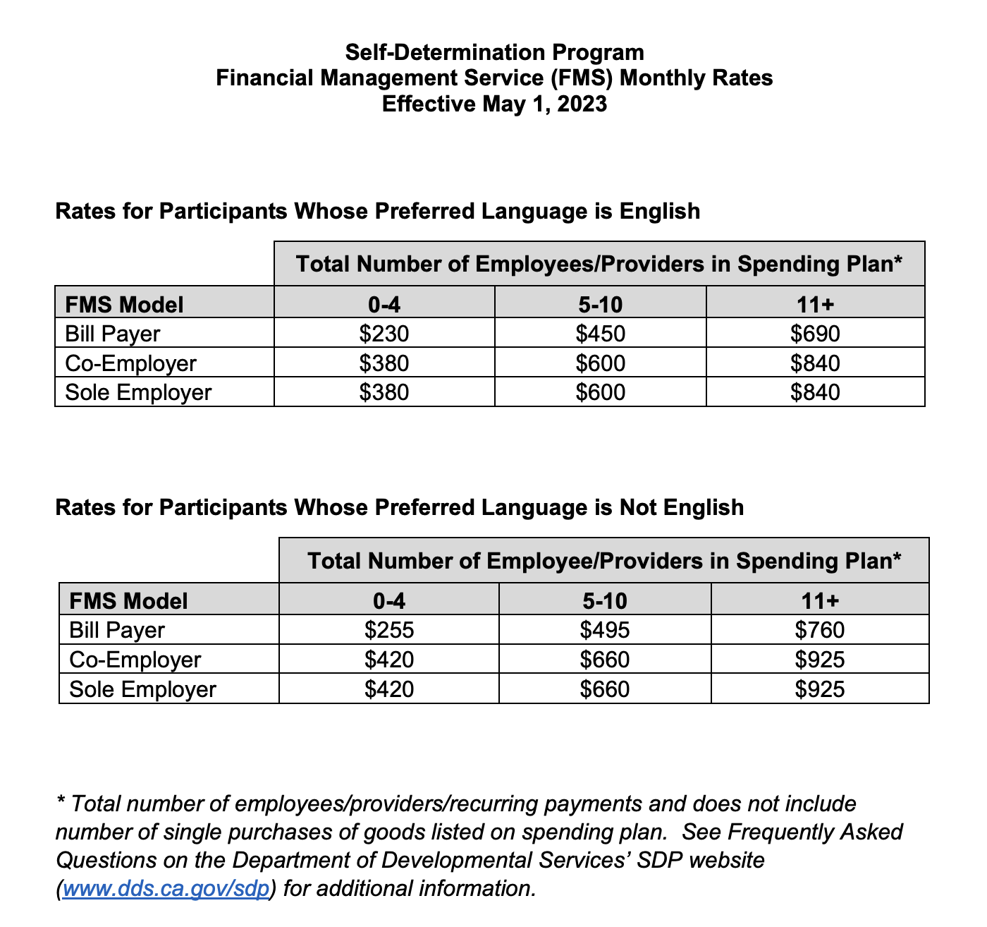

Appendix A - Title Page

RFP TITLE PAGE
Request for Proposal – Fiscal Year 2023-2024

TO: Selection Committee

Regional Center

Program Title (Please Print)

Name of Individual or Organization Submitting Proposal (Please Print)

Address of Individual or Organization Submitting Proposal (Please Print)

Signature of Person Authorized to Bind Organization

Contact Person for Project (Please Print)

Telephone Number of Contact Person

Email Address of Contact Person

Name of Parent Corporations (If Applicable) (Please Print)
________________________________________________________________
Applicant or Organization Contact Person:

Author of Proposal if Different from Individual Submitting Proposal

Appendix B - Financial Statement

Financial Statement
All respondents must complete this statement for the last complete fiscal year and current fiscal year to date.

CURRENT ASSETS | Last FY | Current FY
Cash in Bank
Accounts Receivable
Notes Receivable
Equipment / Vehicles
Inventory
Deposits/ Prepaid Expenses
Life Insurance (Cash Value)
Investment Securities
TOTAL CURRENT ASSETS =
FIXED ASSETS
Buildings and /or Structures
Long Term Investments
Potential Judgements and Liens
TOTAL FIXED ASSETS =
TOTAL CURRENT AND FIXED ASSETS =
CURRENT LIABILITIES

Accounts Payable
Notes Payable
Taxes Payable
TOTAL CURRENT LIABILITIES =
LONG TERM LIABILITIES
Notes / Contracts
Real Estate Mortgages
TOTAL LONG-TERM LIABILITIES =
TOTAL CURRENT AND LONG-TERM LIABILITIES =
Equity =
TOTAL LIABILITIES AND EQUITY =
OTHER INCOME - Revenue from other Sources
(Specify)
LINE OF CREDIT
Amount Available

Appendix C - Statement of Obligations

STATEMENT OF OBLIGATIONS
All applicants must complete this statement

A. 1. Is the applicant currently providing services to people with developmental disabilities?

[ ] No [ ] Yes

If Yes, indicate the following:

Name:
Location:
Type of Service
Capacity

2. Is the applicant currently providing related services to people other than those with developmental disabilities?

[ ] No [ ] Yes

If Yes, indicate the following:

Name:
Location:
Type of Service
Capacity
B. 1. Is the applicant currently receiving grant(s)/funds from any source to develop services for people with developmental disabilities?

[ ] No [ ] Yes

If Yes, indicate the following:

Funding Source:
Scope of Grant Project:

2. Is the applicant currently applying for grant(s)/funds from any source to
develop services for Fiscal Year 2023 – 2024?

[ ] No [ ] Yes

If Yes, indicate the following:

Funding Source:
Scope of Grant Project:

C. Is the applicant planning to expand existing services (through a Letter of Intent and with or without grant funds) from a source other than Regional Center during Fiscal Year 2023 – 2024?

[ ] No [ ] Yes

Provide details:
D. Describe other professional / business obligations. Include the following:
Name:
Location:
Type of Service:
Capacity:

E. Has the applicant, or any member of the applicant’s organization, received a Corrective Action Plan (CAP), Sanction, a Notice of Immediate Danger, an A or B Citations or any other citation from a Regional Center or state licensing agency?

[ ] No [ ] Yes

If Yes, explain in detail:

F. Has the applicant, or any member or staff of the applicant’s organization, ever received a citation from any agency for abuse?

[ ] No [ ] Yes

If Yes, explain in detail:

__________________________________________ ___________
Signature of Applicant or Authorized Representative Date

Appendix D – Proposed Budget for Start-up Cost
(Submit proposed budget for Start-up costs)

Appendix E – Sample Monthly Budget for Ongoing Costs

Item | Projected Cost
1. Salaries and Wages
2. Benefits
3. Consultant Fees
4. Staff Training Costs
5. Mortgage/Lease
Costs
6. Office Supplies/Equipment Costs
7. Consumer Program
Equipment/Supplies
8. Furnishings
9. Household Items
10. Communication
Costs
11. Insurance/Licensing Costs
12. Utility Costs
13. Building Modification
Costs
14. Other (please list)
Estimated Total Cost

Appendix F - Statement of Qualifications/Resumes/References
(Submit full resumes and reference list as attachments here after statement of qualifications)

